Chapter 14, Solution 53.

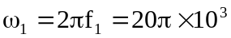
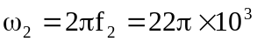

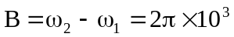
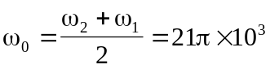
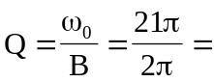10.5

